**Chapter 1 : Introduction**

**Chp 1 -- One Hop Transmission Delay:**

**COMPUTING THE ONE-HOP TRANSMISSION DELAY**

Consider the figure below, in which a single router is transmitting packets, each of length *L* bits, over a single link with transmission rate *R* Mbps to another router at the other end of the link.

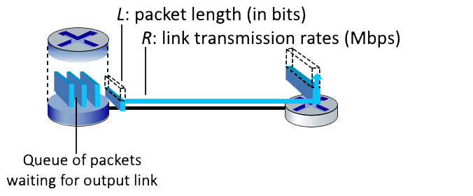

Suppose that the packet length is *L*= 12000 bits, and that the link transmission rate along the link to router on the right is *R* = 10 Mbps.  
  
Round your answer to two decimals after leading zeros

**QUESTION LIST**

1. What is the transmission delay?  
  
2. What is the maximum number of packets per second that can be transmitted by this link?

**SOLUTION**

The transmission delay = **L/R** = 12000 bits / 10000000 bps = 0.0012 seconds  
The number of packets that can be transmitted in a second into the link = **R / L** = 10000000 bps / 12000 bits = 833 packets

**Queueing Delay:**

**QUEUING DELAY**

Consider the queuing delay in a router buffer, where the packet experiences a delay as it waits to be transmitted onto the link. The length of the queuing delay of a specific packet will depend on the number of earlier-arriving packets that are queued and waiting for transmission onto the link. **If the queue is empty and no other packet is currently being transmitted, then our packet’s queuing delay will be zero. On the other hand, if the traffic is heavy and many other packets are also waiting to be transmitted, the queuing delay will be long.**

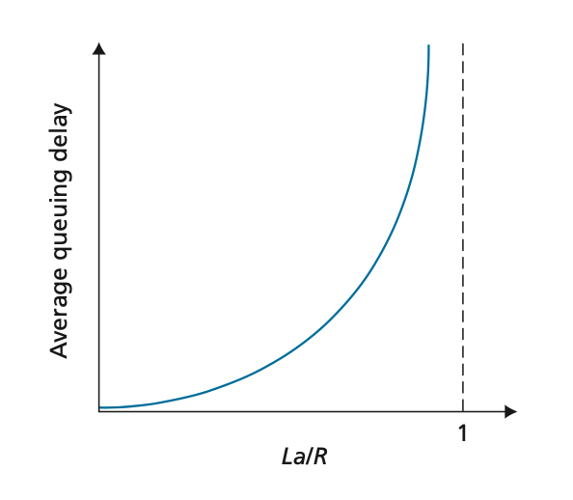

Assume a constant transmission rate of **R = 1100000 bps**, a constant packet-length **L = 3100 bits**, and **a** is the average rate of packets/second.

**Traffic intensity I = La/R**, and the queuing delay is calculated as **I(L/R)(1 - I) for I < 1.**

**QUESTION LIST**

1. In practice, does the queuing delay tend to vary a lot? Answer with Yes or No  
  
2. Assuming that a = 20, what is the queuing delay? Give your answer in milliseconds (ms)  
  
3. Assuming that a = 69, what is the queuing delay? Give your answer in milliseconds (ms)

**SOLUTION**

1 second == 1000 msec

1. Yes, in practice, queuing delay can vary significantly. We use the above formulas as a way to give a rough estimate, but in a real-life scenario it is much more complicated.  
  
2. Queuing Delay = I(L/R)(1 - I) * **1000** = 0.0564*(3100/1100000)*(1-0.0564) * 1000 = 0.15 **ms**.  
  
3. Queuing Delay = I(L/R)(1 - I) * 1000 = 0.1945*(3100/1100000)*(1-0.1945) * 1000 = 0.4415 ms.

**End-to-End Delay: (Transmission and Propagation Delay)**

**COMPUTING END-END DELAY (TRANSMISSION AND PROPAGATION DELAY)**

Consider the figure below, with three links, each with the specified transmission rate and link length.

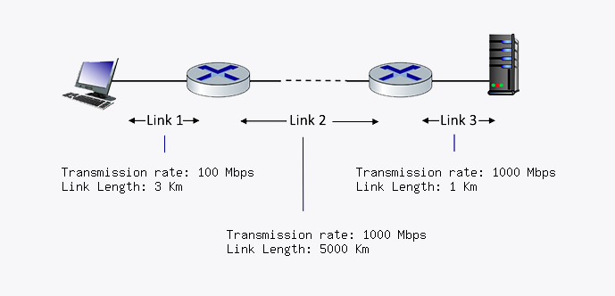

Assume the length of a packet **is 4000 bits**. The speed of light propagation delay on each link is **3x10^8 m/sec**

Round your answer to two decimals after leading zeros

**QUESTION LIST**

1. What is the transmission delay of link 1?  
  
2. What is the propogation delay of link 1?  
  
3. What is the total delay of link 1?  
  
4. What is the transmission delay of link 2?  
  
5. What is the propogation delay of link 2?  
  
6. What is the total delay of link 2?  
  
7. What is the transmission delay of link 3?  
  
8. What is the propogation delay of link 3?  
  
9. What is the total delay of link 3?  
  
10. What is the total delay?

**SOLUTION**

Link 1 transmission delay = **L/R =** 4000 bits / 100 Mbps = 4.00E-5 seconds  
  
Link 1 propagation delay = **d/s** = ()3 Km) * 1000 / 3*10^8 m/sec = 1.00E-5 seconds  
  
Link 1 total delay = **d_t + d_p** = 4.00E-5 seconds + 1.00E-5 seconds = 5.00E-5 seconds  
  
Link 2 transmission delay = **L/R** = 4000 bits / 1000 Mbps = 4.00E-6 seconds  
  
Link 2 propagation delay = **d/s** = ()5000 Km) * 1000 / 3*10^8 m/sec = 0.017 seconds  
  
Link 2 total delay = **d_t + d_p** = 4.00E-6 seconds + 0.017 seconds = 0.017 seconds  
  
Link 3 transmission delay = **L/R** = 4000 bits / 1000 Mbps = 4.00E-6 seconds  
  
Link 3 propagation delay = **d/s** = ()1 Km) * 1000 / 3*10^8 m/sec = 3.33E-6 seconds  
  
Link 3 total delay = **d_t + d_p** = 4.00E-6 seconds + 3.33E-6 seconds = 7.33E-6 seconds  
  
**The total delay = d_L1 + d_L2 + d_L3** = 5.00E-5 seconds + 0.017 seconds + 7.33E-6 seconds = 0.017 seconds

**The IP Stack and Protocol Layering:**

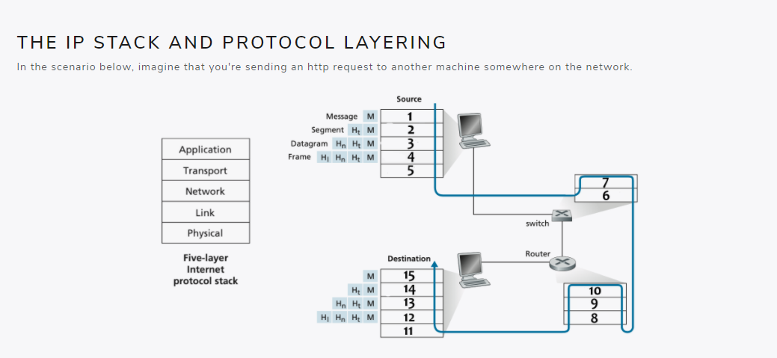

**QUESTION LIST**

1. What layer in the IP stack best corresponds to the phrase: 'handles the delivery of segments from the application layer, may be reliable or unreliable'  
  
2. What layer in the IP stack best corresponds to the phrase: 'handles messages from a variety of network applications'  
  
3. What layer in the IP stack best corresponds to the phrase: 'passes frames from one node to another across some medium'  
  
4. What layer in the IP stack best corresponds to the phrase: 'moves datagrams from the source host to the destination host'  
  
5. What layer in the IP stack best corresponds to the phrase: 'bits live on the wire'  
  
6. What layer corresponds to box 1?  
  
7. What layer corresponds to box 2?  
  
8. What layer corresponds to box 3?  
  
9. What layer corresponds to box 4?  
  
10. What layer corresponds to box 5?  
  
11. What layer corresponds to box 6?  
12. What layer corresponds to box 7?  
  
13. What layer corresponds to box 8?  
  
14. What layer corresponds to box 9?  
  
15. What layer corresponds to box 10?  
  
16. What layer corresponds to box 11?  
  
17. What layer corresponds to box 12?  
  
18. What layer corresponds to box 13?  
  
19. What layer corresponds to box 14?  
  
20. What layer corresponds to box 15?

**SOLUTION**

1. The given phrase corresponds to the Transport Layer.  
  
2. The given phrase corresponds to the Application Layer.  
  
3. The given phrase corresponds to the Link Layer.  
  
4. The given phrase corresponds to the Network Layer.  
  
5. The given phrase corresponds to the Physical Layer.  
  
6. Box 1 is the Application Layer.  
  
7. Box 2 is the Transport Layer.  
  
8. Box 3 is the Network Layer.  
  
9. Box 4 is the Link Layer.  
  
10. Box 5 is the Physical Layer.  
  
11. Box 6 is the Physical Layer.  
  
12. Box 7 is the Link Layer.  
  
13. Box 8 is the Physical Layer.  
  
14. Box 9 is the Link Layer.  
  
15. Box 10 is the Network Layer.  
  
16. Box 11 is the Physical Layer.  
  
17. Box 12 is the Link Layer.  
  
18. Box 13 is the Network Layer.  
  
19. Box 14 is the Transport Layer.  
  
20. Box 15 is the Application Layer.